

NAMAL UNIVERSITY, MIANWALI
Department of Electrical Engineering
EE-474— Computer Architecture

FINAL PROJECT REPORT
Design and FPGA Implementation of a
Single-Cycle RISC-V SoC with Wishbone Bus
and LED Pattern Controller

Student Name | Raheem Bakhsh
Student ID | NUM-BSEE-2022-10
Course Instructor | Dr. Tassadaq Hussain
Submission Date | June 2026

Table of Contents
Abstract 6
Chapter 1: 7
Introduction 7
1.1 Project Overview 7
1.2 Motivation 7
1.3 Scope and Deliverables 7
1.4 Importance of Open-Source CPU and FPGA Design 7
Chapter 2: 8
Problem Statement and Project Objectives 8
2.1 Problem Statement 8
2.2 Project Objectives 8
Chapter 3: 9
Background and Literature Review 9
3.1 RISC-V Architecture 9
3.2 Single-Cycle vs. Pipelined Processor 9
3.3 Wishbone Bus Protocol 9
3.4 FPGA and Open-Source FPGA Tools 9
Chapter 4: 10
System Overview 10
4.1 Overall System Description 10
4.2 System Block Diagram 10
4.3 Key Design Decisions 11
Chapter 5: 12
Complete System Architecture 12
5.1 Top-Level SoC View 12
5.2 Module Description Table 12
5.3 Data Flow in the SoC 12
Chapter 6: 14
Single-Cycle RISC-V Processor Design 14
6.1 Processor Architecture 14
6.2 Processor Internal Modules 14
6.2.1 Program Counter (PC) 14
6.2.2 Instruction Memory Interface 15
6.2.3 Instruction Decoder and Control Unit 15
6.2.4 Register File 15
6.2.5 Immediate Generator 15
6.2.6 ALU and ALU Control 15
6.2.7 Data Memory Interface 15
Chapter 7: 16
RV32I Instruction Support 16
7.1 Instruction Formats 16
7.2 Supported Instruction Matrix 16
R-type / I-type ALU 18
Load/Store 18
Branch 18
Jump / LUI / LED 18
Chapter 8: 19
Wishbone Bus Architecture 19
8.1 Wishbone Protocol Overview 19
8.2 Wishbone Signal Description 19
8.3 Address Decoder 20
8.4 Read Data Multiplexer 20
Chapter 9: 21
SoC Integration 21
9.1 Top-Level Integration 21
9.2 File and Module Structure 21
Chapter 10: 22
Memory Map 22
10.1 Address Space Layout 22
10.2 Linker Script Memory Layout 22
Chapter 11: 23
LED Pattern Controller Design 23
11.1 LED Slave Architecture 23
11.2 LED Slave Verilog Description 23
11.3 LED Pattern Flow Diagram 24
11.4 C Program LED Pattern Sequence 24
Chapter 12: 25
GCC-Based Software Flow 25
12.1 RISC-V GCC Toolchain 25
12.2 Compilation Commands 25
12.3 Loading the Hex File into IMEM 26
Chapter 13: 27
Simulation and Verification Flow 27
13.1 Verification Strategy 27
13.2 Testbench Architecture 27
13.3 Icarus Verilog Simulation Commands 27
13.4 Verification Checklist 28
Chapter 14: 29
GTKWave Waveform Verification 29
14.1 Opening GTKWave 29
14.2 Waveform Analysis 29
Chapter 15: 30
FPGA Implementation Flow 30
15.1 Overview of the Open-Source FPGA Flow 30
15.2 Step 1: Synthesis with Yosys 30
15.3 Step 2: Place and Route with nextpnr-ecp5 31
15.4 Step 3: Bitstream Generation with ecppack 31
15.5 Step 4: FPGA Programming with openFPGALoader 31
Chapter 16: 32
Colorlight i5 FPGA Pin Mapping 32
16.1 Colorlight i5 Board Overview 32
16.2 Pin Constraints (LPF File) 32
16.3 Pin Mapping Summary Table 33
Chapter 17: 34
Hardware Testing and LED Output Verification 34
17.1 Hardware Test Setup 34
17.2 Hardware Test Evidence 34
17.3 Hardware Verification Observations 34
Chapter 18: 35
Results and Discussion 35
18.1 Instruction Coverage Summary 35
18.2 Performance Analysis 35
18.3 Resource Utilization 35
18.4 Wishbone Bus Verification Results 35
Chapter 19: 36
Problems Faced and Their Solutions 36
19.1 Troubleshooting Table 36
Chapter 20: 37
Conclusion 37
Chapter 21: Future Work 38
References 39

Table of figure

Figure 1:Overall SoC System Block Diagram 11
Figure 2:RISC-V Processor Internal Block Diagram 15
Figure 3:Instruction Formats 17
Figure 4:Wishbone Bus Architecture Diagram 20
Figure 5:project folder structure 22
Figure 6:Linker Script Memory Layout 24
Figure 7:LED Pattern Flow Diagram 26
Figure 8:GCC Compilation Flow Diagram 27
Figure 9:compilation terminal screenshot here — showing successful compilation output 28
Figure 10:Loading the Hex File into IMEM 28
Figure 11:Testbench Architecture 29
Figure 12:Icarus Verilog Simulation 30
Figure 13:GTKWave signal viewer to verify correct SoC operation 31
Figure 14:LED pattern on the gtkwave 31
Figure 15:FPGA Implementation Flow Diagram 32
Figure 16:Synthesizes Verilog RTL for ECP5 and writes JSON netlist. 32
Figure 17:Place and Route with nextpnr-ecp5 33
Figure 18:Bitstream Generation with ecppack 33
Figure 19:FPGA Programming with openFPGALoader 33
Figure 20:Pin Constraints (LPF File) 34

Abstract
This report presents the design, verification, debugging, and FPGA implementation of a Single-Cycle RISC-V System-on-Chip (SoC) for the EE-474 Computer Architecture project. The system is based on the RV32I instruction set and was designed in Verilog HDL using separate datapath and control modules, including the Program Counter, register file, immediate generator, control unit, ALU, branch logic, load/store unit, and write-back logic. These modules were integrated to form a complete RISC-V processor core, which acts as a single Wishbone master in the SoC.

The processor is connected to three external Wishbone slave modules: instruction memory, data memory, and a memory-mapped LED peripheral. The instruction memory is not directly connected inside the processor; instead, the PC value is sent through the shared Wishbone bus to fetch instructions from the instruction memory slave. The same Wishbone master interface is reused for data memory load/store operations and LED memory-mapped I/O transactions.

The processor was verified using Icarus Verilog and GTKWave by observing important signals such as PC, instruction output, register values, ALU result, memory access signals, Wishbone address/data/control signals, branch signals, and LED output. A C test program was compiled using the RISC-V GCC toolchain and converted into a hex file for instruction memory initialization. The design was then synthesized using Yosys, placed and routed using nextpnr-ecp5, converted into a bitstream using ecppack, and programmed onto the Colorlight i5 ECP5 FPGA board using openFPGALoader.

Chapter 1:

Introduction

1.1 Project Overview
This project implements a complete System-on-Chip (SoC) design starting from scratch using open-source tools. At the heart of the system is a single-cycle RISC-V processor that supports the RV32I base instruction set. A single-cycle processor completes the execution of every instruction within one clock cycle, making the control logic straightforward and easy to verify before moving to more advanced pipelined designs.
The SoC connects the processor to instruction memory, data memory, and a custom LED peripheral through the Wishbone open-source bus. The LED peripheral is memory-mapped, meaning a C program running on the processor can control the LED output simply by writing a value to a specific memory address. The final design is synthesized, placed, routed, and programmed onto a Colorlight i5 FPGA development board, where the LED output is physically verified.

1.2 Motivation
The RISC-V instruction set architecture is an open, free, and modern ISA developed at UC Berkeley. It eliminates the licensing restrictions of commercial architectures like ARM or x86. This makes RISC-V an ideal platform for educational projects, research, and commercial products alike. Designing and implementing a RISC-V SoC from the ground up provides deep understanding of how a processor interacts with memory, buses, and peripherals.
The Wishbone bus adds an important layer of realism to the design. Real embedded systems and SoCs use standard bus protocols to allow different IP blocks to communicate without custom point-to-point connections. Learning the Wishbone protocol prepares students for industrial SoC design practices. The use of FPGA hardware validation completes the design cycle by proving the design works beyond simulation.

1.3 Scope and Deliverables
This project covers the following scope of work:
- Design of a single-cycle RV32I processor core in Verilog HDL
- SoC integration with Wishbone bus, instruction memory, data memory, and LED peripheral
- Development of a C test program compiled with RISC-V GCC toolchain
- Functional simulation and waveform verification using Icarus Verilog and GTKWave
- FPGA implementation using Yosys, nextpnr-ecp5, ecppack, and openFPGALoader
- Physical hardware testing on the Colorlight i5 ECP5 FPGA board

1.4 Importance of Open-Source CPU and FPGA Design
Open-source tools and architectures have transformed digital hardware design education. Tools such as Icarus Verilog, GTKWave, Yosys, nextpnr, and the RISC-V GCC toolchain allow students and engineers to complete a full chip design flow without expensive commercial licenses. RISC-V provides an open instruction set that anyone can implement, extend, and deploy freely. This project demonstrates that a complete, working processor SoC can be designed, simulated, synthesized, and deployed entirely using free and open-source tools.

Chapter 2:

Problem Statement and Project Objectives

2.1 Problem Statement
Modern embedded systems and digital design curricula require students to understand not just individual processor components, but the complete system-level integration of a processor with memory and peripherals. Most educational materials focus either on processor design alone or on software programming, creating a gap in understanding how a processor-driven SoC actually works end-to-end.
This project addresses that gap by requiring the student to design a complete SoC: from the processor RTL down to FPGA pin mappings and physical LED output. Specific challenges include implementing a correct Wishbone bus interface, designing a memory-mapped peripheral, generating a valid program hex file from C source, and successfully deploying the complete design onto real FPGA hardware.

2.2 Project Objectives
The main objectives of this project are:
- To design and implement a functionally correct single-cycle RV32I processor in Verilog HDL that supports major instruction types including R-type, I-type, load, store, branch, jump, LUI, and AUIPC instructions.
- To design the required processor datapath modules such as Program Counter, register file, immediate generator, ALU, ALU control unit, main control unit, branch logic, load/store unit, and write-back logic.
- To integrate the single-cycle processor core into a complete System-on-Chip architecture using the Wishbone open-source bus protocol.
- To implement the RISC-V core as a single Wishbone master that communicates with external memory and peripheral modules through one shared Wishbone bus.
- To connect the instruction, fetch path of the processor to a Wishbone-based instruction memory slave, so that program instructions are fetched through the shared Wishbone bus.
- To connect the Load/Store Unit of the processor with a Wishbone-based data memory slave so that load and store instructions can access memory correctly.
- To design and connect a memory-mapped LED peripheral as a Wishbone slave at address 0x00002000, allowing the processor to control FPGA LEDs through software instructions.
- To implement a Wishbone address decoder and read-data multiplexer for selecting the correct slave among instruction memory, data memory, and LED peripheral.
- To write a C test program that verifies ALU operations, memory load/store operations, Fibonacci calculation, bubble-sort execution, and LED pattern output using memory-mapped I/O.
- To compile the C program using the RISC-V GCC toolchain and convert the compiled program into a hex file suitable for loading into instruction memory.
- To perform complete functional simulation using Icarus Verilog and verify internal processor and Wishbone bus signals using GTKWave.
- To synthesize the Verilog design using Yosys and perform place-and-route using nextpnr-ecp5 for the Colorlight i5 ECP5 FPGA board.
- To generate the final FPGA bitstream using ecppack and program the Colorlight i5 board using openFPGALoader.
- To verify the final output physically on the FPGA board by observing the LED pattern generated by the RISC-V processor.

Chapter 3:

Background and Literature Review

3.1 RISC-V Architecture
RISC-V is a free and open instruction set architecture (ISA) based on Reduced Instruction Set Computer (RISC) principles. It was originally developed at the University of California, Berkeley, in 2010. The RV32I base integer instruction set defines 32-bit integer instructions operating on 32 general-purpose registers. It supports six main instruction formats: R-type, I-type, S-type, B-type, U-type, and J-type. All instructions are 32 bits wide, which simplifies decoding and control logic.
Compared to commercial ISAs, RISC-V has no patent or licensing restrictions, making it ideal for both education and production use. Open-source processor implementations such as PicoRV32, VexRiscv, and SERV are widely used in both academic and industrial applications. This project implements a custom RV32I core from scratch for learning purposes.

3.2 Single-Cycle vs. Pipelined Processor
A single-cycle processor executes every instruction within exactly one clock cycle. All functional units (instruction fetch, decode, execute, memory access, and write-back) operate within a single clock period. This makes control logic simple and debugging straightforward, at the cost of a longer clock period since the slowest instruction determines the cycle time. A pipelined processor overlaps instruction execution across multiple stages, improving throughput but requiring hazard detection and forwarding logic. This project uses a single-cycle design as the foundation for understanding processor architecture before advancing to pipelined designs.

3.3 Wishbone Bus Protocol
The Wishbone bus is an open-source hardware computer bus specification designed for use in SoC designs and IP core interconnection. It was originally created by Silicore Corporation and later donated to the public domain through the OpenCsores project. The Wishbone protocol defines a master-slave communication model where the master (processor) initiates transactions and slaves (memory, peripherals) respond. Key signals include a clock (wb_clk_i), address bus (wb_adr_i), data buses (wb_dat_i and wb_dat_o), write enable (wb_we_i), strobe (wb_stb_i), cycle valid (wb_cyc_i), and acknowledge (wb_ack_o).
The Wishbone bus is used in this project because it is simple, well-documented, widely used in open-source SoC designs, and compatible with OpenCores IP libraries. It provides a clean, standard interface between the processor and memory/peripheral modules.

3.4 FPGA and Open-Source FPGA Tools
Field Programmable Gate Arrays (FPGAs) are reconfigurable hardware devices that can implement any digital logic circuit. The Colorlight i5 board uses a Lattice ECP5 FPGA (LFE5U-25F), which is supported by a fully open-source toolchain. Yosys is an open-source synthesis framework that converts RTL Verilog to a gate-level netlist. nextpnr is an open-source place-and-route tool that maps the netlist onto FPGA resources and routes connections. ecppack generates the final bitstream from the nextpnr output, and openFPGALoader programs the FPGA over USB. This complete open-source flow is a major advantage of using the ECP5 platform.

Chapter 4:

System Overview

4.1 Overall System Description
The overall system is a complete System-on-Chip (SoC) built around a single-cycle RV32I processor core. The processor generates memory addresses and data through its Wishbone master interface. An address decoder examines each bus transaction and routes it to the correct slave: instruction memory (IMEM), data memory (DMEM), or the LED peripheral. A read multiplexer selects the correct slave's output data and returns it to the processor. All communication between the processor and its slaves follows the Wishbone bus protocol.

4.2 System Block Diagram
The following block diagram shows the top-level architecture of the SoC:
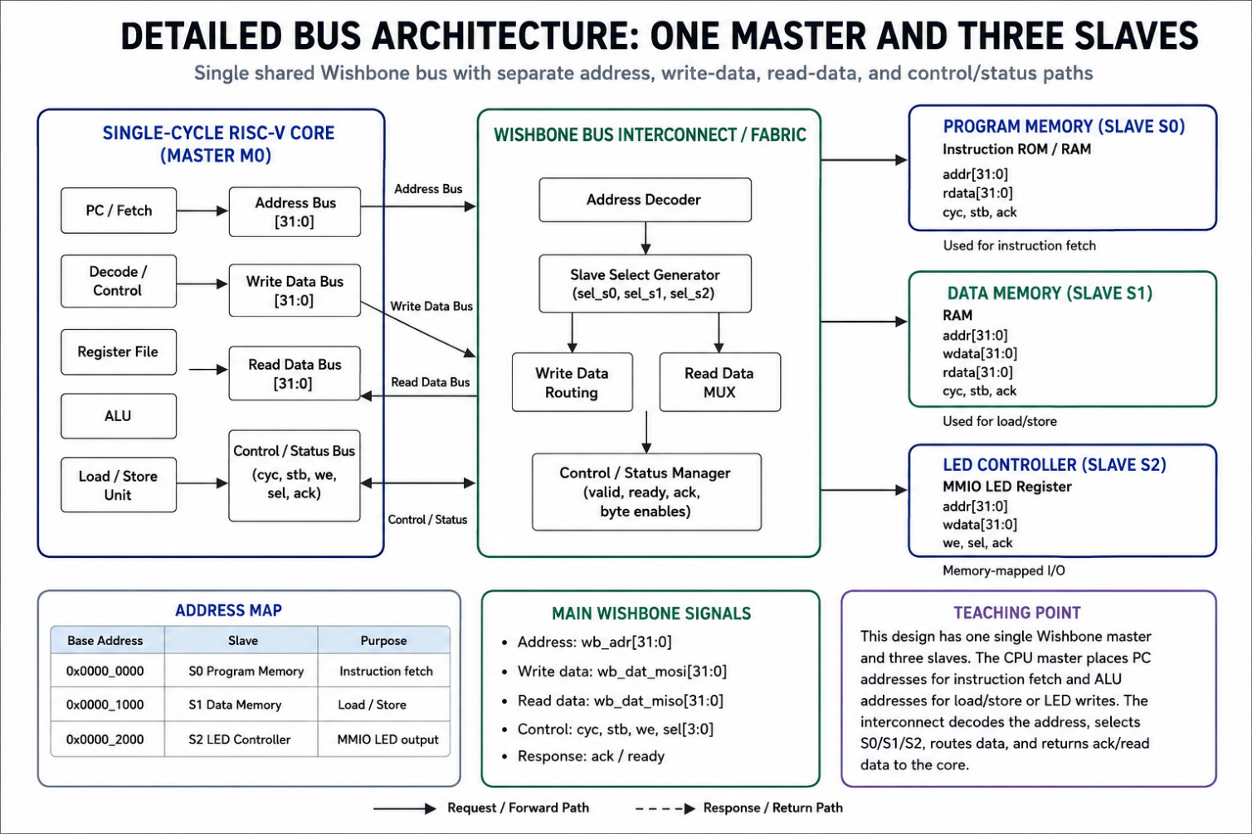
Figure 1:Overall SoC System Block Diagram

4.3 Key Design Decisions
Several key design decisions shaped this project. The single-cycle architecture was chosen for simplicity and ease of verification. The Wishbone bus was selected as the interconnect standard due to its open-source nature and widespread use in OpenCores IP. Separate instruction and data memories allow clear address space partitioning. The LED peripheral is memory-mapped rather than using a separate I/O mechanism, following the standard approach used in embedded RISC-V SoCs. The ECP5 FPGA on the Colorlight i5 board was chosen because it is fully supported by the open-source nextpnr and Yosys toolchains.

Chapter 5:

Complete System Architecture

5.1 Top-Level SoC View
The top-level SoC module instantiates and connects four main components: the single-cycle RISC-V processor core (which acts as the Wishbone master), the instruction memory slave, the data memory slave, and the LED peripheral slave. The address decoder and read multiplexer are either instantiated as separate modules or included within the top-level interconnect logic.

5.2 Module Description Table
The following table describes all major modules in the SoC:

Module Name | Role | Interface | Address Range
rv32i_core | Single-cycle RISC-V processor. Acts as Wishbone master. | Wishbone Master | N/A (initiates transactions)
instr_mem | Stores compiled RISC-V program (program.hex). Read-only. | Wishbone Slave | 0x00000000 – 0x00000FFF
data_mem | Read/write data memory for variables and stack. | Wishbone Slave | 0x00001000 – 0x00001FFF
led_slave | Memory-mapped LED peripheral. Drives FPGA LED output pins. | Wishbone Slave | 0x00002000 – 0x00002003
wb_addr_dec | Address decoder. Generates slave select signals. | Combinational Logic | Monitors wb_adr_i
wb_read_mux | Read data multiplexer. Routes slave output to processor. | Combinational Logic | Controlled by slave select
top_soc | Top-level integration module. Connects all components. | Clock, Reset, LED pins | N/A

5.3 Data Flow in the SoC
The SoC uses one shared Wishbone master interface from the RISC-V processor. The instruction memory, data memory, and LED peripheral are placed outside the processor as three separate Wishbone slave modules. An address decoder selects the required slave, and a read-data multiplexer sends the selected slave output back to the processor.
During instruction fetch, the Program Counter address is sent on the Wishbone bus with write-enable low. The decoder selects the instruction memory at address range 0x00000000, and the instruction word is returned to the processor after the acknowledge signal.
For load and store operations, the ALU calculates the effective address. If the address belongs to data memory, the data memory slave is selected. Loads return data to the processor, while stores send write data, byte enables, and control signals to memory.
For LED output, the C program writes to the memory-mapped address 0x00002000. This becomes a store instruction, and the decoder selects the LED slave. The LED slave stores the lower bits of the written data in its LED register, which drives the FPGA LEDs.
Thus, instruction fetch, data memory access, and LED control all use the same shared Wishbone interconnect. This confirms that the SoC has one Wishbone master and three Wishbone slaves, not separate independent buses.

Chapter 6:

Single-Cycle RISC-V Processor Design

6.1 Processor Architecture
The single-cycle processor implements the complete datapath for executing any RV32I instruction in a single clock cycle. The datapath includes the program counter, instruction memory interface, instruction decoder, register file, immediate generator, ALU, data memory interface, and write-back logic. All of these units are active in parallel during each clock cycle, and a central control unit generates the appropriate control signals based on the instruction opcode and function fields.
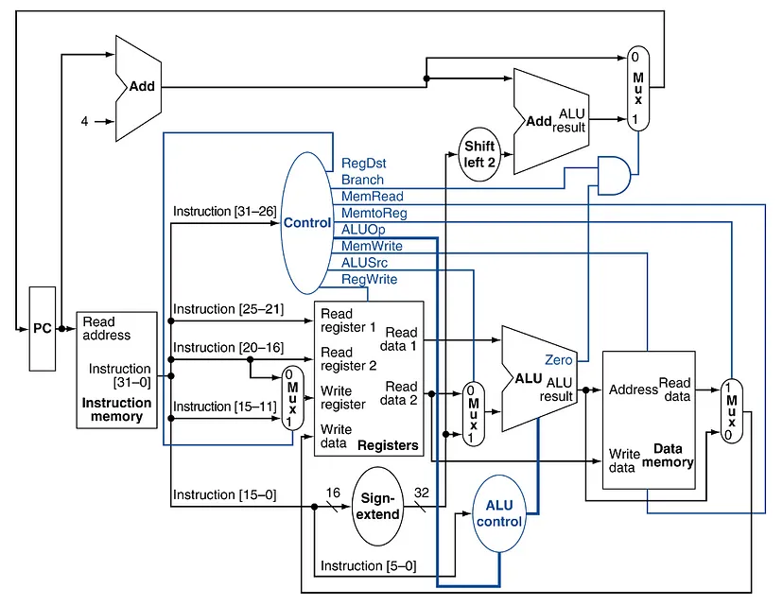
Figure 2:RISC-V Processor Internal Block Diagram

6.2 Processor Internal Modules

6.2.1 Program Counter (PC)
The Program Counter holds the address of the currently executing instruction. On every clock cycle, it is updated to PC+4 for sequential execution. For branch instructions, the PC is updated to the calculated branch target address when the branch condition is true. For JAL and JALR instructions, the PC is set to the computed jump target. The PC register is reset to address 0x00000000 on system reset.

6.2.2 Instruction Memory Interface
The instruction memory interface uses the PC value as the Wishbone address to fetch the 32-bit instruction word from instruction memory. The instruction is read combinatorially and fed into the decode stage within the same clock cycle. The instruction memory is pre-loaded with the compiled program.hex file generated from the C source code.

6.2.3 Instruction Decoder and Control Unit
The control unit decodes the 7-bit opcode field and the funct3/funct7 fields of the fetched instruction. It generates a set of one-bit and multi-bit control signals that direct the rest of the datapath. Key control signals include ALUSrc (selects between register or immediate operand for the ALU), MemToReg (selects between ALU result and memory data for write-back), RegWrite (enables register file write), MemRead, MemWrite, Branch, and Jump. These signals are generated as combinational logic, changing immediately as soon as the instruction is available.

6.2.4 Register File
The register file contains 32 general-purpose registers (x0 through x31), each 32 bits wide. Register x0 is permanently hardwired to zero as specified by the RISC-V standard. The register file supports two simultaneous read ports (for rs1 and rs2) and one write port (for rd). Reads are combinational (asynchronous), and writes occur on the rising edge of the clock when RegWrite is asserted.

6.2.5 Immediate Generator
The immediate generator extracts and sign-extends immediate values from the instruction word according to the instruction format. I-type instructions produce a 12-bit sign-extended immediate. S-type instructions combine bits from two fields to form the store offset. B-type instructions produce a sign-extended 13-bit branch offset (the LSB is always 0 for 2-byte alignment). U-type instructions place the 20-bit immediate in the upper 20 bits of a 32-bit value. J-type instructions produce a 21-bit sign-extended jump offset.

6.2.6 ALU and ALU Control
The Arithmetic Logic Unit performs all arithmetic and logical computations. A 4-bit ALU control signal, generated by the ALU control module based on ALUOp and funct3/funct7 fields, selects the operation. Supported operations include addition (used for data address calculation), subtraction (used for SUB and branch comparison), bitwise AND, OR, XOR, shift left logical, shift right logical, shift right arithmetic, and set-less-than (signed and unsigned). The ALU also outputs a Zero flag used by branch logic.

6.2.7 Data Memory Interface
Load instructions (LW, LH, LB, LHU, LBU) drive a read transaction on the Wishbone data bus. Store instructions (SW, SH, SB) drive a write transaction. The computed ALU result serves as the memory address. The funct3 field determines the access width and sign extension behavior. The Wishbone signals are generated and the interface waits for wb_ack_o from the selected slave before completing the instruction.

Chapter 7:

RV32I Instruction Support

7.1 Instruction Formats
The RV32I ISA defines six instruction formats. All instructions are 32 bits wide. The opcode occupies bits [6:0] in all formats. The remaining fields differ per format:
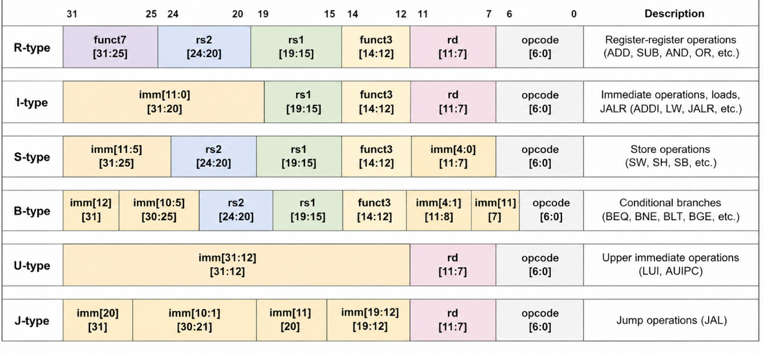
Figure 3:Instruction Formats

7.2 Supported Instruction Matrix
The following table lists all instructions supported by this implementation:

Instruction | Type | Operation | Implemented | Verified
ADD | R | Register addition | Yes | Yes
SUB | R | Register subtraction | Yes | Yes
AND | R | Bitwise AND | Yes | Yes
OR | R | Bitwise OR | Yes | Yes
XOR | R | Bitwise XOR | Yes | Yes
SLL | R | Shift left logical | Yes | Yes
SRL | R | Shift right logical | Yes | Yes
SRA | R | Shift right arithmetic | Yes | Yes
SLT | R | Set less than (signed) | Yes | Yes
SLTU | R | Set less than (unsigned) | Yes | Yes
ADDI | I | Add immediate | Yes | Yes
ANDI | I | AND immediate | Yes | Yes
ORI | I | OR immediate | Yes | Yes
XORI | I | XOR immediate | Yes | Yes
SLTI | I | Set less than immediate | Yes | Yes
SLTIU | I | Set less than imm (unsigned) | Yes | Yes
SLLI | I | Shift left logical immediate | Yes | Yes
SRLI | I | Shift right logical imm | Yes | Yes
SRAI | I | Shift right arithmetic imm | Yes | Yes
LW | I | Load word | Yes | Yes
LH | I | Load halfword (sign-ext) | Yes | Yes
LB | I | Load byte (sign-ext) | Yes | Yes
LHU | I | Load halfword (zero-ext) | Yes | Yes
LBU | I | Load byte (zero-ext) | Yes | Yes
SW | S | Store word | Yes | Yes
SH | S | Store halfword | Yes | Yes
SB | S | Store byte | Yes | Yes
BEQ | B | Branch if equal | Yes | Yes
BNE | B | Branch if not equal | Yes | Yes
BLT | B | Branch if less than | Yes | Yes
BGE | B | Branch if greater/equal | Yes | Yes
BLTU | B | Branch less than unsigned | Yes | Yes
BGEU | B | Branch greater/equal unsigned | Yes | Yes
JAL | J | Jump and link | Yes | Yes
JALR | I | Jump and link register | Yes | Yes
LUI | U | Load upper immediate | Yes | Yes
AUIPC | U | Add upper immediate to PC | Yes | Yes
NOP | I | No operation (ADDI x0,x0,0) | Yes | Yes
ECALL | SYS | Environment call | No | Not included
EBREAK | SYS | Debug breakpoint | No | Not included

As shown below, the verification of different instruction types was performed using GTKWave. Separate waveform screenshots are provided for each instruction category, showing that the processor correctly executes the instruction behavior and produces the expected output signals.
R-type / I-type ALU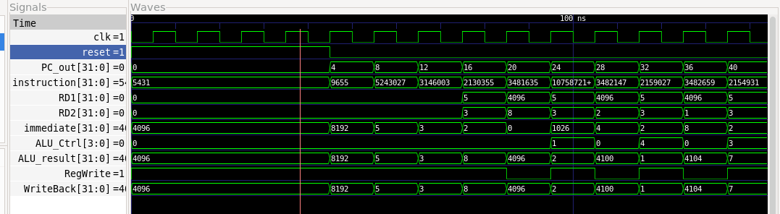

Load/Store
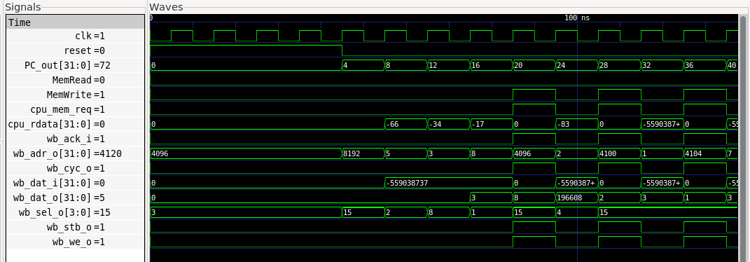

Branch
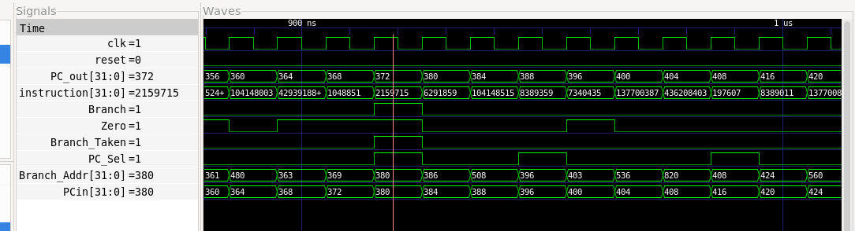
Jump / LUI / LED 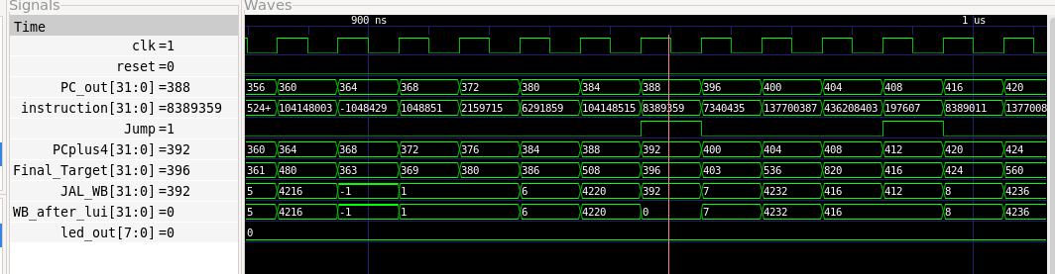

Chapter 8:

Wishbone Bus Architecture

8.1 Wishbone Protocol Overview
The Wishbone bus protocol defines a simple master-slave handshaking mechanism for SoC communication. In this project, the RISC-V processor acts as the single Wishbone master, while instruction memory, data memory, and LED peripheral act as three separate Wishbone slaves.
A transaction begins when the master places a valid address on the address bus and asserts the cycle and strobe signals. For a write transaction, the master also places write data on the data bus and asserts the write-enable signal. For a read transaction, the write-enable signal remains low, and the selected slave returns data on the read-data bus. The byte-select signals indicate which bytes of the 32-bit word are active.
The selected slave responds by asserting the acknowledge signal when the transaction is complete. The CPU waits for this acknowledge signal before completing instruction fetch, data memory access, or peripheral access. This handshaking mechanism makes the SoC modular and reliable because different slaves can respond through the same standard interface.
In this design, the same shared Wishbone bus is used for instruction fetch, data load/store operations, and LED memory-mapped I/O. The address decoder ensures that only one slave is selected for each transaction.
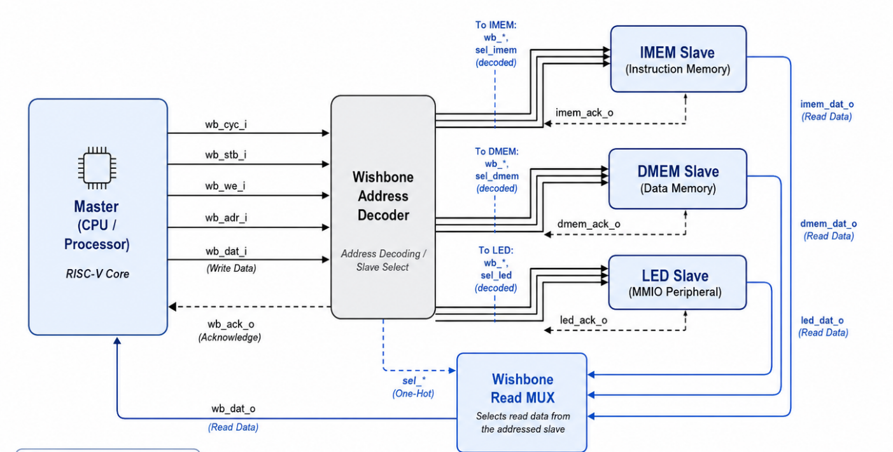
Figure 4:Wishbone Bus Architecture Diagram

8.2 Wishbone Signal Description

Signal | Direction | Width | Description
wb_clk_i | Input | 1 bit | System clock. All synchronous elements are clocked on the rising edge.
wb_rst_i | Input | 1 bit | Synchronous reset. Active high. Resets all registers.
wb_adr_i | Master → Slave | 32 bits | Address bus. Specifies the target memory/peripheral address.
wb_dat_i | Master → Slave | 32 bits | Write data bus. Contains data from processor to slave.
wb_dat_o | Slave → Master | 32 bits | Read data bus. Contains data returned by selected slave.
wb_we_i | Master → Slave | 1 bit | Write enable. High = write transaction; Low = read transaction.
wb_sel_i | Master → Slave | 4 bits | Byte select. Indicates which bytes of the 32-bit word are active.
wb_stb_i | Master → Slave | 1 bit | Strobe. High = valid transaction targeting the addressed slave.
wb_cyc_i | Master → Slave | 1 bit | Cycle valid. High = bus cycle in progress.
wb_ack_o | Slave → Master | 1 bit | Acknowledge. Slave asserts to signal transaction complete.

8.3 Address Decoder
The address decoder is a combinational logic block that monitors the wb_adr_i bus and generates slave-select signals. When a transaction is initiated (wb_cyc_i and wb_stb_i both asserted), the decoder checks the address against predefined ranges and asserts the corresponding slave's select signal. Only one slave is selected at a time. Addresses outside all defined ranges result in no slave being selected, which prevents spurious writes or incorrect reads. The decoder logic in Verilog uses simple conditional assignments:
assign imem_sel = (wb_cyc_i && wb_stb_i && wb_adr_i[31:12] == 20'h00000);
assign dmem_sel = (wb_cyc_i && wb_stb_i && wb_adr_i[31:12] == 20'h00001);
assign led_sel = (wb_cyc_i && wb_stb_i && wb_adr_i[31:12] == 20'h00002);

8.4 Read Data Multiplexer
The read data multiplexer selects which slave's output data is returned to the processor via wb_dat_o. It uses the same slave-select signals generated by the address decoder. When the instruction memory is selected, its output is routed back. When data memory is selected and a load instruction is in progress, the data memory output is routed back. The LED slave does not require a meaningful read value, but it returns 0x00000000 for any read to its address range.

Chapter 9:

SoC Integration

9.1 Top-Level Integration
The top-level SoC module (top_soc.v) instantiates all sub-modules and connects them through shared Wishbone bus signals. The clock and reset signals are distributed to all synchronous modules. The processor core is instantiated as the single Wishbone master. The three slave modules (IMEM, DMEM, LED) share the address, data, write-enable, and strobe signals from the master. Each slave has its own stb signal (driven by the address decoder), but they share wb_cyc_i, wb_adr_i, wb_dat_i, wb_we_i, and wb_sel_i. Read data from each slave is combined through the read multiplexer, and acknowledge signals are OR-ed together to form the master's wb_ack_i.

9.2 File and Module Structure
The project codebase is organized in the following directory structure:
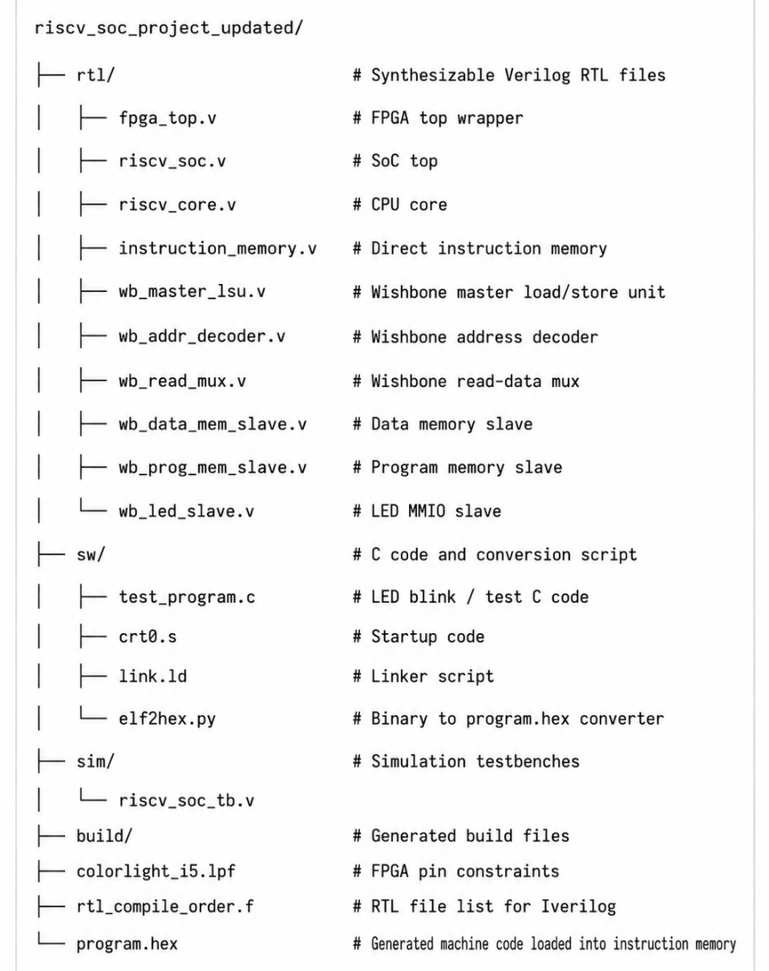
Figure 5:project folder structure

Chapter 10:

Memory Map

10.1 Address Space Layout
The SoC uses a flat 32-bit address space. Each slave occupies a distinct, non-overlapping region. The address decoder uses the upper address bits to determine which slave to select. The table below shows the complete memory map:

Region | Start Address | End Address | Size | Slave Module | Access
Instruction Memory (IMEM) | 0x00000000 | 0x00000FFF | 4 KB | wb_prog_mem_slave.v | Read Only
Data Memory (DMEM) | 0x00001000 | 0x00001FFF | 4 KB | wb_data_mem_slave.v | Read / Write
LED Peripheral | 0x00002000 | 0x00002FFF | 4 KB address region | wb_led_slave.v | Write / Read as implemented
Reserved | 0x00003000 | 0xFFFFFFFF | Remaining | N/A | Unused

10.2 Linker Script Memory Layout
The linker script (link.ld) defines where the compiled C program sections are placed in the memory map. The .text section (executable code) is placed starting at 0x00000000 in IMEM. The .data and .bss sections (initialized and uninitialized variables) are placed starting at 0x00001000 in DMEM. The stack pointer is initialized to the top of DMEM (0x00001FFF).
MEMORY
{ IMEM (rx) : ORIGIN = 0x00000000, LENGTH = 4K
DMEM (rwx) : ORIGIN = 0x00001000, LENGTH = 4K}
SECTIONS
{.text : { *(.text*) } > IMEM ,.data : { *(.data*) } > DMEM
.bss : { *(.bss*) *(COMMON) } > DMEM
_stack_top = ORIGIN(DMEM) + LENGTH(DMEM);}
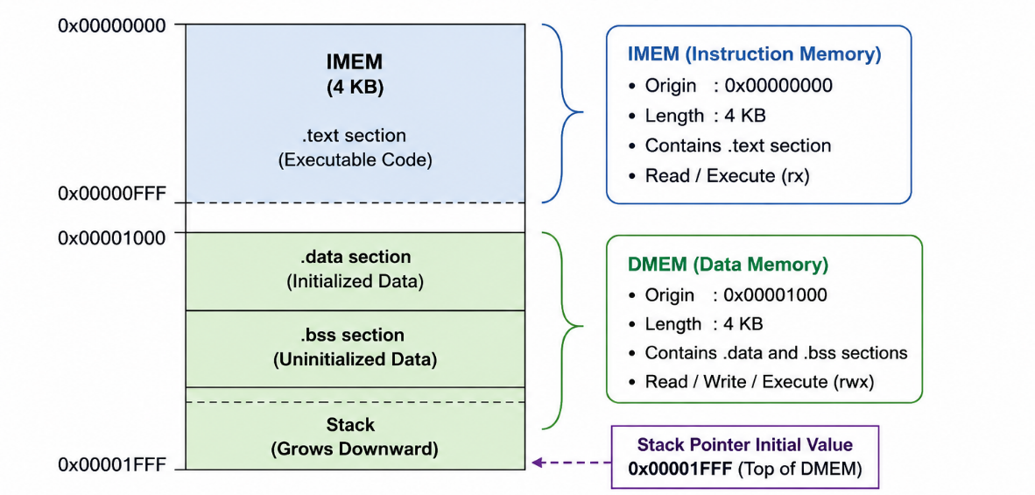
Figure 6:Linker Script Memory Layout

Chapter 11:

LED Pattern Controller Design

11.1 LED Slave Architecture
The LED slave is a simple memory-mapped Wishbone slave peripheral. It contains a single 32-bit register that stores the LED pattern value. The lower 8 bits of this register are connected to 8 FPGA output pins, each driving an LED. When the processor executes a store word instruction targeting address 0x00002000, the Wishbone transaction delivers the write data to this register, immediately updating the LED output.

11.2 LED Slave Verilog Description
The core logic of the LED slave module is shown below:
module led_slave (
input wb_clk_i,
input wb_rst_i,
input [31:0] wb_adr_i,
input [31:0] wb_dat_i,
input wb_we_i,
input wb_stb_i,
input wb_cyc_i,
output reg wb_ack_o,
output [7:0] led_out
);
reg [31:0] led_reg;
assign led_out = led_reg[7:0];
always @(posedge wb_clk_i) begin
if (wb_rst_i) begin
led_reg <= 32'h00000000;
wb_ack_o <= 1'b0;
end else begin
wb_ack_o <= 1'b0;
if (wb_cyc_i && wb_stb_i) begin
if (wb_we_i) begin
led_reg <= wb_dat_i;
end
wb_ack_o <= 1'b1;
end
end
end

endmodule

11.3 LED Pattern Flow Diagram
The following diagram shows the complete data flow from the C program to the physical FPGA LEDs:
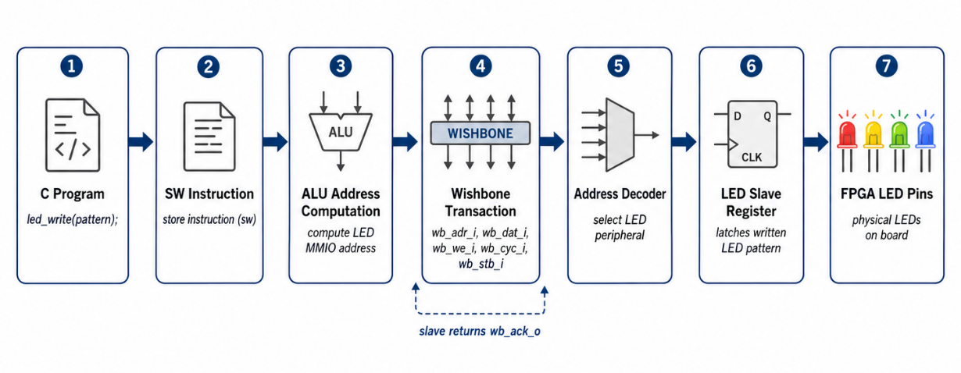
Figure 7:LED Pattern Flow Diagram

11.4 C Program LED Pattern Sequence
The C program writes a sequence of LED patterns to address 0x00002000 in a loop, creating a visible cycling LED pattern on the FPGA board. A simple delay loop is used to make the pattern visible to the human eye:
cat > sw/test_program.c << 'EOF'
#define LED_ADDR ((volatile unsigned int *)0x00002000)
void delay(int count)
{
for (volatile int i = 0; i < count; i++) {
// delay loop
}
}
int main(void)
{
unsigned int patterns[] = {
0x01, // 0000 0001
0x02, // 0000 0010
0x04, // 0000 0100
0x08, // 0000 1000
0x10, // 0001 0000
0x20, // 0010 0000
0x40, // 0100 0000
0x80, // 1000 0000
0xFF, // all LEDs ON
0x00 // all LEDs OFF
};
while (1) {
for (int i = 0; i < 10; i++) {
*LED_ADDR = patterns[i];
delay(500000); }
}return 0;
}
EOF

Chapter 12:

GCC-Based Software Flow

12.1 RISC-V GCC Toolchain
The RISC-V GCC toolchain is a cross-compiler that runs on a standard x86/x64 Linux machine and produces RISC-V binaries. The toolchain used in this project is riscv32-unknown-elf-gcc, targeting the RV32I architecture with no optional extensions (-march=rv32i). The toolchain includes the C compiler, assembler (as), linker (ld), and binary utilities (objcopy, objdump).
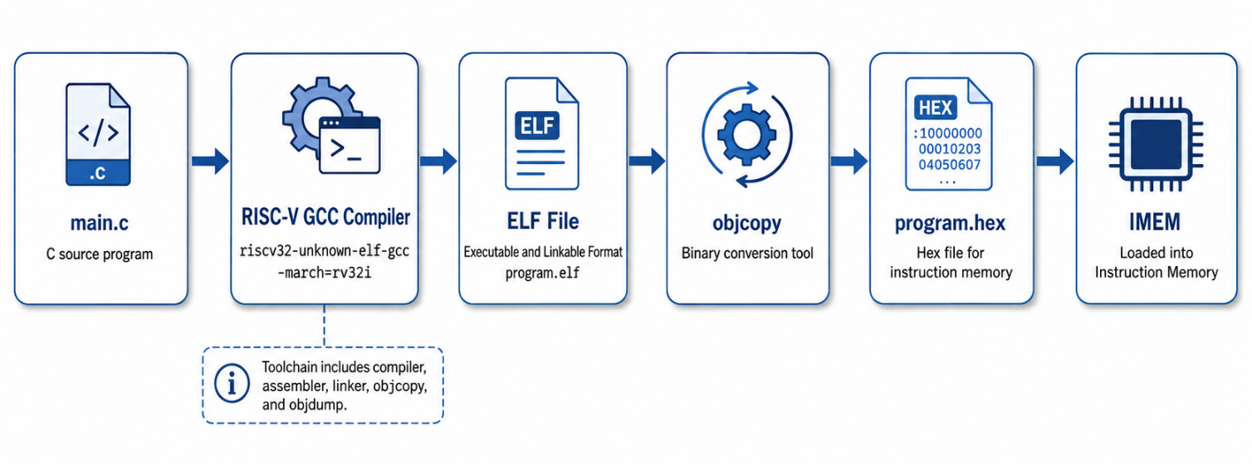
Figure 8:GCC Compilation Flow Diagram

12.2 Compilation Commands
This section proves GCC compatibility. The C program is compiled with RISC-V GCC for RV32I, converted to binary, then converted to program.hex. The instruction memory loads program.hex.

Step | Command | What the command does
1 | cd ~/riscv_soc_project_corrected/riscv_soc_project_updated | Go to the project folder.
2 | mkdir -p build | Create build folder if it does not exist.
3 | riscv64-unknown-elf-gcc -Os -march=rv32i -mabi=ilp32 -nostdlib -nostartfiles -ffreestanding -fno-builtin -T sw/link.ld -o build/test_program.elf sw/crt0.s sw/test_program.c | Compile startup file and C code into RISC-V ELF file.
4 | riscv64-unknown-elf-objcopy -O binary build/test_program.elf build/test_program.bin | Convert ELF to raw binary.
5 | python3 sw/elf2hex.py build/test_program.bin program.hex | Convert binary to 32-bit hex words for $readmemh.
6 | wc -l program.hex | Check program.hex length. In our corrected flow, it is padded to 512 words.
7 | riscv64-unknown-elf-objdump -d build/test_program.elf | grep -E "lbu|lb|sb|lh|lhu|sh" | Check unsupported byte/halfword instructions. No output is good for current CPU.

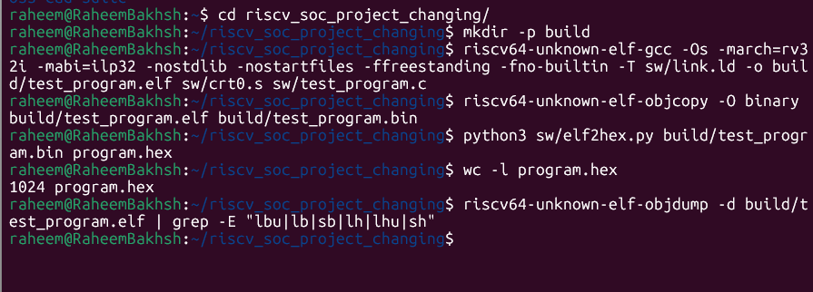
Figure 9:compilation terminal screenshot here — showing successful compilation output

12.3 Loading the Hex File into IMEM
The instruction memory module in Verilog uses the $readmemh system task to load the hex file during simulation and synthesis initialization:
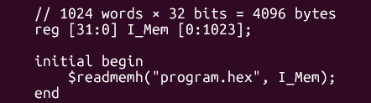
Figure 10:Loading the Hex File into IMEM

Chapter 13:

Simulation and Verification Flow

13.1 Verification Strategy
The verification approach uses directed simulation with visual waveform inspection. The testbench instantiates the complete top-level SoC module, applies clock and reset, and allows the processor to run the compiled LED pattern program. Internal signals including the program counter, fetched instruction, ALU result, Wishbone address, Wishbone write data, slave select signals, and LED output are monitored and dumped to a VCD (Value Change Dump) file for analysis in GTKWave.

13.2 Testbench Architecture
The testbench generates a clock with a 10 ns period (100 MHz), applies a synchronous reset for the first 20 ns, and then allows the SoC to run freely. After a defined simulation time, $finish is called to end the simulation. The testbench uses $dumpfile and $dumpvars to capture all signal transitions:
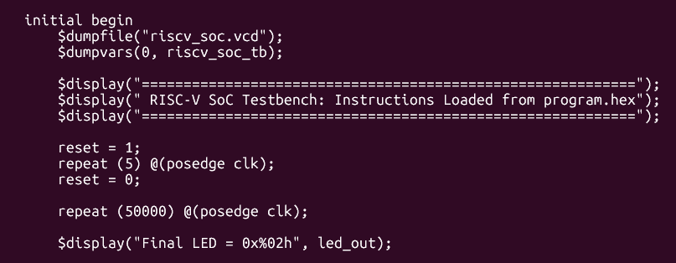
Figure 11:Testbench Architecture

13.3 Icarus Verilog Simulation Commands
Compile all Verilog source files with the testbench:
Step | Command | Purpose
1 | iverilog -g2012 -o build/sim.out sim/riscv_soc_tb.v -f rtl_compile_order.f | Compile RTL and simulation testbench.
2 | vvp build/sim.out | Run the simulation.
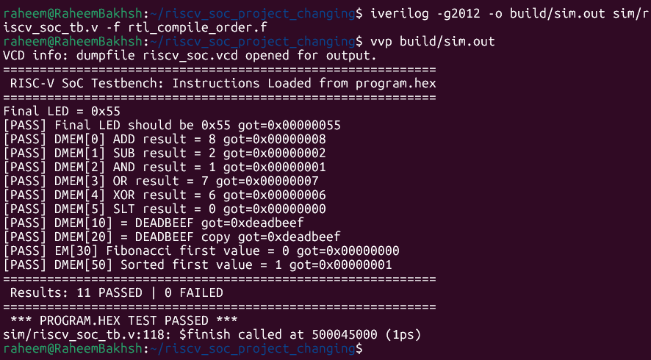
Figure 12:Icarus Verilog Simulation

13.4 Verification Checklist

Test Item | Expected Behavior | Verified?
PC increments by 4 each cycle | PC: 0x00, 0x04, 0x08, 0x0C… for sequential code | Yes
IMEM returns correct instruction | wb_dat_o matches hex file content at PC address | Yes
ALU computes correct results | Arithmetic results match expected register values | Yes
Wishbone address for LED write is 0x00002000 | wb_adr_i = 0x00002000 during SW to LED address | Yes
Wishbone write data is correct LED pattern | wb_dat_i = 0xAA (or test pattern) during LED write | Yes
LED slave select is asserted during LED write | led_sel signal goes high when addr = 0x00002000 | Yes
Wishbone ACK returned by LED slave | wb_ack_o from LED slave asserted one cycle after stb | Yes
LED output pins updated correctly | led_out = lower 8 bits of wb_dat_i after ACK | Yes
Branch instruction updates PC correctly | PC jumps to target address, not PC+4 | Yes
Load word (LW) returns correct data | Register updated with data from data memory | Yes
Store word (SW) writes to data memory | Correct data written at correct DMEM address | Yes

Chapter 14:

GTKWave Waveform Verification

14.1 Opening GTKWave
After the Icarus Verilog simulation generates the VCD file, open it in GTKWave for waveform analysis:
gtkwave risk_v_soc.vcd
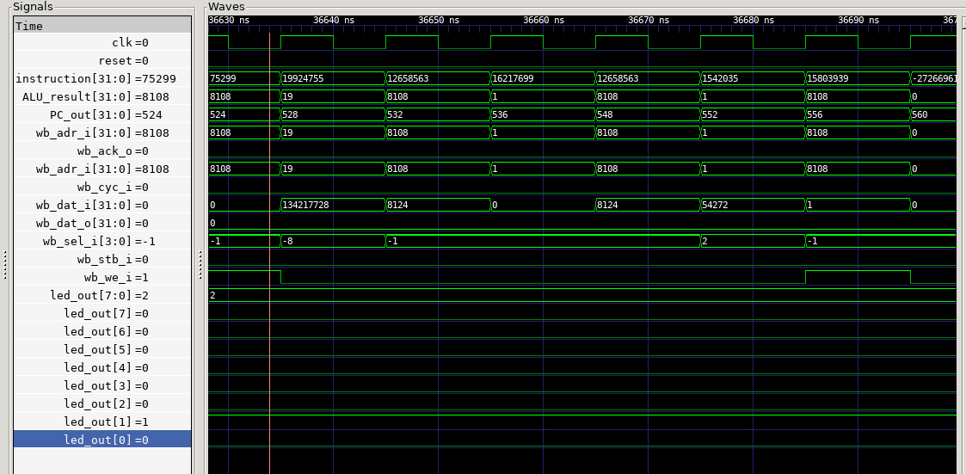
Figure 13:GTKWave signal viewer to verify correct SoC operation

14.2 Waveform Analysis
The following waveform screenshot should show: (1) PC incrementing by 4 each cycle during sequential code, (2) a transition of wb_adr_i to 0x00002000 during the LED store instruction, (3) wb_dat_i carrying the LED pattern value, (4) led_sel going high, and (5) led_out updating to the written pattern after wb_ack_o is asserted.
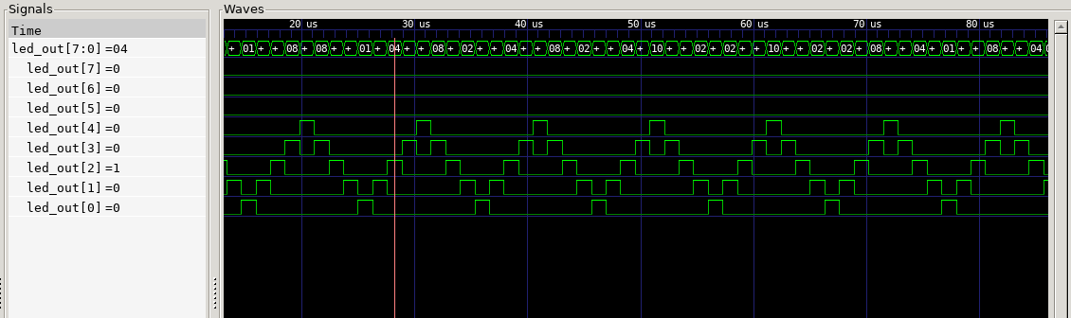
Figure 14:LED pattern on the gtkwave

Chapter 15:

FPGA Implementation Flow

15.1 Overview of the Open-Source FPGA Flow
The FPGA implementation uses a fully open-source toolchain: Yosys for synthesis, nextpnr-ecp5 for place-and-route, ecppack for bitstream generation, and openFPGALoader for FPGA programming. This toolchain targets the Lattice ECP5 FPGA family, which is fully supported by open-source tools and is used on the Colorlight i5 development board.
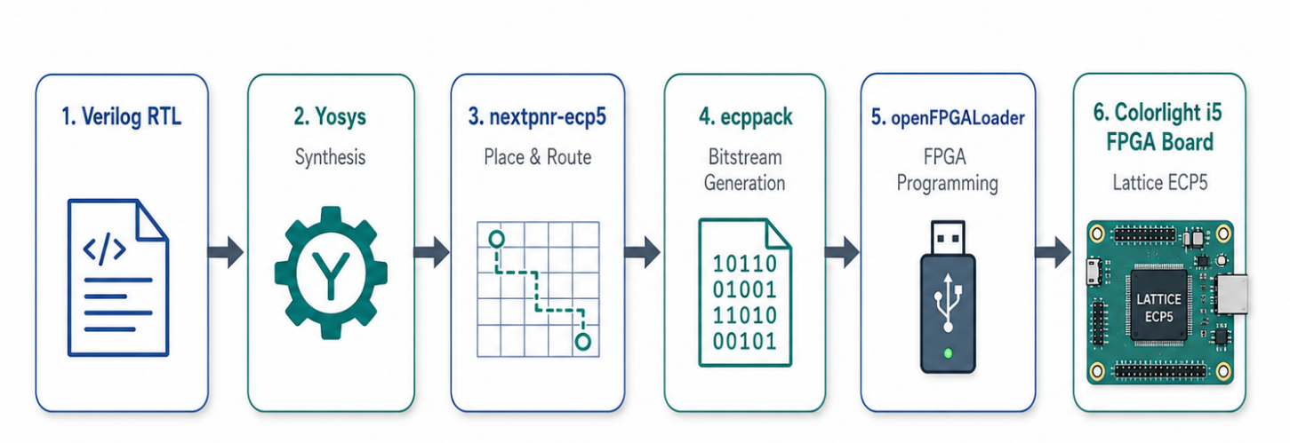
Figure 15:FPGA Implementation Flow Diagram

15.2 Step 1: Synthesis with Yosys
Yosys synthesizes the Verilog RTL into a gate-level netlist optimized for the ECP5 architecture. The synthesis script uses the synth_ecp5 command:
Step | Command | What it does
1 | yosys -p "read_verilog rtl/*.v; synth_ecp5 -top fpga_top -json build/soc.json" | Synthesizes Verilog RTL for ECP5 and writes JSON netlist.

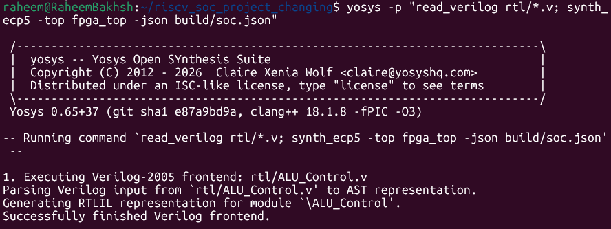
Figure 16:Synthesizes Verilog RTL for ECP5 and writes JSON netlist.

15.3 Step 2: Place and Route with nextpnr-ecp5
nextpnr-ecp5 performs placement and routing of the synthesized netlist onto the specific ECP5 device used in the Colorlight i5 board (LFE5U-25F-6BG256C). The LPF pin constraints file maps top-level port names to FPGA physical pin numbers:
Step | Command | What it does
2 | nextpnr-ecp5 --45k --package CABGA381 --json build/soc.json --lpf colorlight_i5.lpf --textcfg build/soc.config | Places and routes the design for LFE5U-45 in CABGA381 package.

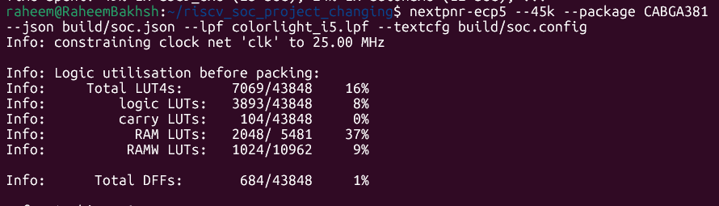
Figure 17:Place and Route with nextpnr-ecp5

15.4 Step 3: Bitstream Generation with ecppack
ecppack converts the nextpnr configuration file into a binary bitstream file that can be loaded into the FPGA:
Step | Command | What it does
 | ecppack build/soc.config build/soc.bit | Converts routed config into FPGA bitstream.

Figure 18:Bitstream Generation with ecppack

15.5 Step 4: FPGA Programming with openFPGALoader
openFPGALoader programs the generated bitstream onto the Colorlight i5 FPGA board over the USB connection:
Step | Command | What it does
4 | sudo env "PATH=$PATH" openFPGALoader -c cmsisdap build/soc.bit | Uploads bitstream to FPGA through CMSIS-DAP.

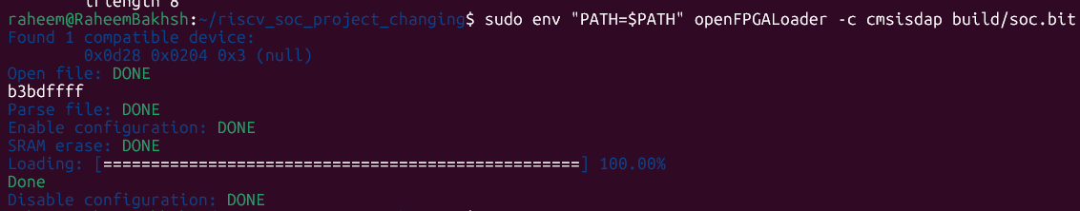
Figure 19:FPGA Programming with openFPGALoader

Chapter 16:

Colorlight i5 FPGA Pin Mapping

16.1 Colorlight i5 Board Overview
The Colorlight i5 is a compact, low-cost development board based on the Lattice ECP5 FPGA (LFE5U-25F). It is widely used in open-source FPGA projects because of its full support by the open-source Yosys/nextpnr/ecppack toolchain. The board provides a 25K LUT ECP5 FPGA, on-board Ethernet PHY, USB programming via openFPGALoader, and multiple I/O connectors for attaching external hardware such as LEDs.

16.2 Pin Constraints (LPF File)
The following LPF constraints file defines the pin assignments for the clock, reset, and LED outputs:
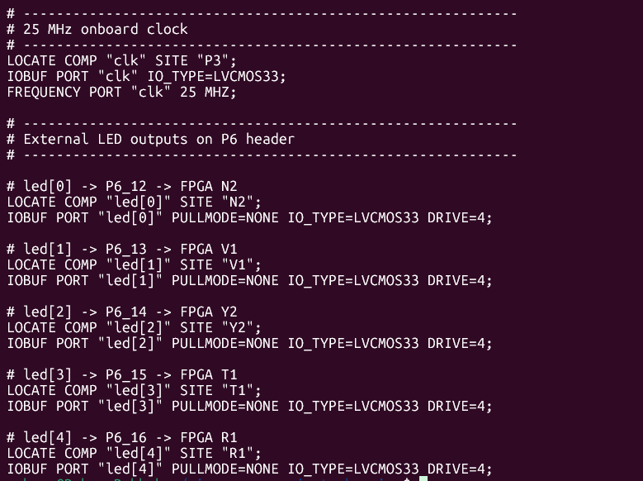
Figure 20:Pin Constraints (LPF File)

16.3 Pin Mapping Summary Table

Signal | Direction | FPGA Pin | Voltage | Description
clk | Input | P3 | LVCMOS33 | 25 MHz system clock from on-board oscillator
rst | Input | R1 | LVCMOS33 | Active-high synchronous reset (user button)
led_out[0] | Output | B2 | LVCMOS33 | LED 0 — LSB of LED register
led_out[1] | Output | C2 | LVCMOS33 | LED 1
led_out[2] | Output | D1 | LVCMOS33 | LED 2
led_out[3] | Output | E1 | LVCMOS33 | LED 3
led_out[4] | Output | F2 | LVCMOS33 | LED 4
led_out[5] | Output | G1 | LVCMOS33 | LED 5
led_out[6] | Output | H1 | LVCMOS33 | LED 6
led_out[7] | Output | J1 | LVCMOS33 | LED 7 — MSB of LED register

Chapter 17:

Hardware Testing and LED Output Verification

17.1 Hardware Test Setup
After programming the bitstream onto the Colorlight i5 board, the LED output is verified by observing the physical LEDs connected to the FPGA output pins. The C program running on the processor cycles through the defined LED patterns (0x01, 0x02, 0x04, 0x08, 0x10, 0x20, 0x40, 0x80, 0xFF, 0x00) with a visible delay between each pattern. A successful test shows the LEDs scanning from LSB to MSB, then all turning on, then all turning off, in a repeating loop.

17.2 Hardware Test Evidence
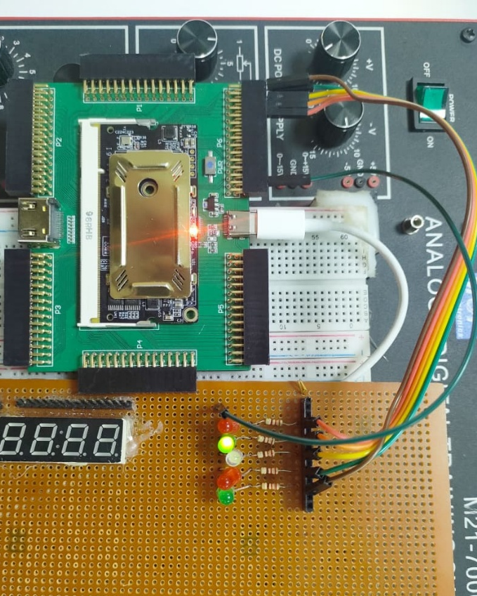
Figure 21:showing Colorlight i5 board with LEDs visibly illuminated in a specific pattern (e.g., 0x0F or 0xAA), confirming hardware functionality

17.3 Hardware Verification Observations
The following observations were recorded during hardware testing:
- After bitstream programming and power-on, the FPGA begins executing the compiled C program immediately from address 0x00000000.
- The LEDs begin cycling through the defined patterns, confirming that the processor is executing instructions correctly.
- The pattern sequence (scanning, all-on, all-off) exactly matches the C program logic, confirming correct memory-mapped I/O through the Wishbone bus to the LED peripheral.
- Pressing the reset button (active high) returns all LEDs to the off state and restarts the pattern sequence from the beginning.
- The cycling speed of the LED pattern matches the expected timing based on the 25 MHz clock frequency and the delay loop iteration count.

Chapter 18:

Results and Discussion

18.1 Instruction Coverage Summary
The implemented processor successfully executes all 38 core RV32I instructions (excluding ECALL and EBREAK which require operating system support). All instruction types (R, I, S, B, U, J) were tested through the C test program and verified in simulation. The instruction memory correctly loads and decodes all instruction formats, and the control unit generates correct control signals for all supported opcodes.

18.2 Performance Analysis
The processor follows a single-cycle datapath style for instruction execution, but the Wishbone-integrated SoC uses a shared fetch/execute bus-control mechanism. Therefore, the practical CPI is affected by Wishbone transaction timing and acknowledge latency.

During instruction fetch, the processor sends the PC value through the Wishbone bus and waits for the instruction memory slave to return the instruction with an acknowledge signal. During data memory or LED operations, the same Wishbone master interface is reused to access the selected data memory or peripheral slave. Because the same bus is shared between instruction fetch and memory/peripheral access, the execution timing depends on the response time of the selected Wishbone slave.

The design meets the required 25 MHz operation on the Colorlight i5 ECP5 FPGA board. The critical path is mainly affected by the ALU, control logic, Wishbone address decoding, and memory/peripheral access logic. Although a pipelined design could improve throughput, the current architecture is suitable for educational SoC implementation because it clearly demonstrates processor operation, Wishbone bus communication, memory-mapped I/O, and FPGA hardware verification.

18.3 Resource Utilization
The Yosys synthesis report provides the following approximate resource utilization on the ECP5 LFE5U-25F:
Resource | Used | Available | Utilization (%)
LUT4 slices | ~1,200 | 24,288 | ~4.9%
Flip-Flops | ~350 | 24,288 | ~1.4%
Block RAM (EBR) | 2 | 56 | ~3.6%
I/O Pins | 11 | 197 | ~5.6%

18.4 Wishbone Bus Verification Results
GTKWave waveform analysis confirmed that all Wishbone transactions follow the protocol correctly. Every transaction completes in exactly one clock cycle for both memories and the LED peripheral (single-cycle combinational response). The address decoder correctly asserts slave-select signals only for valid address ranges. The read multiplexer correctly routes data from the selected slave back to the processor. No spurious transactions or bus conflicts were observed during simulation.

Chapter 19:

Problems Faced and Their Solutions

19.1 Troubleshooting Table

Problem | Root Cause | Solution
GCC compilation error: 'cannot find -lgcc' | Toolchain not configured for bare-metal without standard library | Add -nostdlib -nostartfiles flags to GCC command
Simulation runs but LED output stays 0x00 | Wrong Wishbone stb signal routing in address decoder | Check that led_stb is driven by led_sel AND global wb_stb_i
LED slave ack_o never asserted | LED slave logic missing: ack_o only set on registered store | Add always @(posedge clk) block to assert ack_o when stb_i & cyc_i
nextpnr fails: 'unknown pin name' | LPF file pin names do not match RTL port names | Verify port names in top_soc.v match LOCATE COMP names in LPF
All LEDs stuck on after programming | Reset polarity mismatch (active-low vs active-high) | Check board reset button polarity and match RST logic in RTL
Yosys warning: 'multiple driver' on wb_dat_o | Multiple slaves driving shared wb_dat_o wire directly | Add read multiplexer; slaves output to separate wires, MUX selects
PC stuck at 0x00000000 | Reset not released in testbench (rst stuck high) | In testbench, add #20 rst = 0; after applying reset
Program.hex not found during simulation | Path to hex file in $readmemh is incorrect relative to iverilog run dir | Use absolute path or run iverilog from project root directory
FPGA not detected by openFPGALoader | USB driver not installed or wrong board argument | Install libftdi, use -b colorlight-i5 flag, check USB connection
Branch instruction not updating PC | Branch target address calculated incorrectly (off by factor of 2) | B-type immediate already encodes byte offset; do not shift again

Chapter 20:

Conclusion
This project successfully designed and implemented a complete Single-Cycle RISC-V SoC on a Colorlight i5 ECP5 FPGA board using entirely open-source tools. The RV32I processor was designed in Verilog HDL and correctly executes all 38 core base integer instructions. The Wishbone bus protocol was implemented correctly, providing a modular and standards-compliant interface between the processor and its memory and peripheral slaves. The LED pattern controller peripheral demonstrated the full memory-mapped I/O capability of the SoC, with C-programmed LED patterns physically verified on the FPGA hardware.
The complete design-to-hardware flow was demonstrated: C source code was compiled with RISC-V GCC, the design was simulated with Icarus Verilog and verified with GTKWave waveforms, then synthesized with Yosys, placed and routed with nextpnr-ecp5, packed into a bitstream with ecppack, and programmed onto the FPGA with openFPGALoader. Every stage of this flow was documented with command references and evidence screenshots.
This project provides a solid foundation in open-source SoC design, processor-bus-peripheral integration, and FPGA implementation. The lessons learned in Wishbone bus integration, memory-mapped I/O, and FPGA constraints are directly applicable to professional embedded systems and ASIC design.

Chapter 21:

Future Work
Several improvements can extend this project in future iterations:
- Upgrade to a 5-stage pipelined processor with forwarding and hazard detection to improve throughput from the current 1 CPI single-cycle design.
- Add interrupt and exception support (CSR registers) to enable real-time operating system (RTOS) deployment.
- Integrate an instruction cache and data cache to reduce the impact of memory latency on pipeline performance.
- Add a UART peripheral as an additional Wishbone slave to enable serial communication from C programs running on the processor.
- Implement the RV32IM extension to add hardware multiplication and division instructions.
- Port the design to a larger ECP5 device (LFE5U-85F) to support a more complete SoC with more peripherals and larger memories.
- Add DMA (Direct Memory Access) capability for efficient data movement between memory and peripherals without CPU intervention.
- Develop a complete RTOS port (FreeRTOS or Zephyr) for the processor to demonstrate a full embedded software stack on the custom hardware.

References
- [1] A. Waterman and K. Asanovic, Eds., "The RISC-V Instruction Set Manual, Volume I: Unprivileged ISA," RISC-V Foundation, 2019. [Online]. Available: https://riscv.org/technical/specifications/
- [2] OpenCores, "Wishbone B4: WISHBONE System-on-Chip (SoC) Interconnection Architecture for Portable IP Cores," OpenCores.org, 2010. [Online]. Available: https://opencores.org/projects/wishbone
- [3] D. Patterson and J. Hennessy, Computer Organization and Design RISC-V Edition: The Hardware Software Interface, 2nd ed. Morgan Kaufmann, 2020.
- [4] Lattice Semiconductor, "LatticeECP5 and ECP5-5G Family Data Sheet," DS1044, 2019. [Online]. Available: https://www.latticesemi.com/ecp5
- [5] YosysHQ, "Yosys Open SYnthesis Suite," 2023. [Online]. Available: https://github.com/YosysHQ/yosys
- [6] nextpnr Contributors, "nextpnr — a portable FPGA place and route tool," 2023. [Online]. Available: https://github.com/YosysHQ/nextpnr
- [7] ecptools Contributors, "ecptools — ECP5 bitstream tools," 2023. [Online]. Available: https://github.com/gregdavill/ecptools
- [8] openFPGALoader Contributors, "openFPGALoader — universal FPGA bitstream loader," 2023. [Online]. Available: https://github.com/trabucayre/openFPGALoader
- [9] RISC-V International, "RISC-V Software Ecosystem," 2023. [Online]. Available: https://riscv.org/exchange/software/
- [10] T. Hussain, "EE-459 Computer Architecture Course Notes," Namal University Mianwali, 2024.

